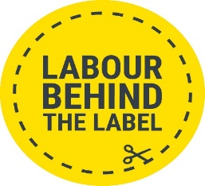

7th November 2023

Rishi Sunak, Prime Minister
Kevin Hollinrake, Parliamentary Under-Secretary of State for Enterprise, Markets and Small Business
Margaret Beels, Director of Labour Market Enforcement
cc: Peter Soulsby, Mayor of Leicester City Council
cc: Philip Dunne, Environmental Audit Committee
cc: Human Rights at Work Joint Committee

Ref: Urgent Action Needed for Leicester Garment Workers and Recommendations for long term sustainable garment industry in the UK.

The most recent BBC Panorama programme on 6th November provides a snapshot into the ongoing exploitation of workers and the lack of oversight in fashion company supply chains in the UK. The investigation highlights the continued unfair and abusive purchasing practices which squeeze suppliers on prices and lead times. In turn this impacts worker who are underpaid, harassed and forced into insecure jobs. The past decade has seen numerous reports detailing similar practices in Leicester garment factories, and other factories both in the UK and internationally. The situation was also investigated during the 2019 Environmental Audit Committee investigation into Fast Fashion and concerns were raised in Parliament in December 2020.

Alleged abuses within the garment industry in Leicester share many characteristics of the global exploitation of workers in fashion brand supply chains globally. Boohoo is not alone in failing workers in its supply chain – cases of abuse are found wherever big brands manufacture. These abuses include furlough fraud, modern slavery, abusive working conditions, widespread wage theft and the exploitation of vulnerable workers. Continued use of unfair purchasing practices drives illegal employment practices, and there needs to be action to effectively improve the enforcement of labour rights and stop persistent unfair purchasing practices.

We previously welcomed this Government’s steps to address the working conditions of the UK’s most vulnerable workers including discussions around revising the Modern Slavery Act, the Taylor review on modern working practices, and the creation of a Single Enforcement Body. It is clear however, that much more effective and pro-active action needs to be taken, especially given the lack of progress made.

The Government failed once again to take a meaningful step forward in overseeing the poor behaviour and abusive purchasing practices of brands in 2020 when our report into the Leicester garment industry was released. Instead, the government set up a (another) Task Force looking solely at enforcement. Operation tacit has undertaken good work in visiting suppliers and monitoring poor practices. However, it has failed and will fail to get to the heart of the abuses and endemic underpayment in the UK because it is limited to enforcement agencies alone and because the UK government still insists on linking immigration enforcement to labour market enforcement.
It also failed because it failed to address one of the key causes of workplace abuse in the garment industry and that is exploitative and unethical purchasing practices such as low pricing, unilateral discounts, bullying and lack of communication. We ask that you take urgent steps to legislating, monitoring, and remedying labour rights and address the issue of purchasing practices.

It comes as no surprise that exploitation continues right at the heart of England. Labour market agencies are woefully under resourced and there is a continued lack of importance placed on the enforcement of labour rights and minimum wage compliance. Action is needed both to ensure all workers in the Leicester garment industry and worldwide are protected by labour and health and safety laws and in curbing the abusive, potentially illegal purchasing practices by clothing retailers and brands which have contributed to this situation. The Environmental Audit Committee recommended March 2021 that the UK government establish Garment Trading Adjudicator, modelling it on the successful Groceries Code Adjudicator that stops unfair purchasing practices by UK’s largest food retailers. Establishing a Garment Trading Adjudicator already has the support of more than 60 MPs.

At the same time, there is an opportunity in the UK to build a more sustainable and ethical garment industry, building on the work of certain brands, NGOs and importantly the trade unions in supporting worker voice, enabling union access into workplaces, and addressing wage theft. Leicester has a skilled workforce and yet brands insist on sourcing overseas in the search for ever cheaper labour costs. The industry in Leicester is ready for innovative and sustainable manufacturing. It offers production in the UK reducing transport costs and carbon emissions. The UK is supposed to be one of the leading economies in the world, with a robust legislation and there is the opportunity to build a thriving industry in Leicester with the commitment of brands and the government. This would provide workers with decent work, with stability and manufacturers with the confidence to invest in the workforce.

However, it is crucial that the underlying drivers of abuse are identified so long-term solutions can be developed.

We, the undersigned, ask the Government to take the following urgent steps:

- Protect all workers in the Leicester garment industry and ensure that timely remedy, including payment of unpaid wages and so on, is provided to those who have been the victims of non-payment or underpayment of wages and benefits (wage theft), furlough fraud, unsafe environments, and modern slavery.

- Ensure that the government works with stakeholders, including unions and workers to examine the underlying causes of exploitation.

- Ensure that the government invests in labour market enforcement agencies including ensuring sufficient transparency and collaboration between agencies and among the community.

- Establish a Garment Trading Adjudicator to help stop unfair purchasing practices by the largest clothing retailers and brands operating in the UK market.

- Work towards the implementation of due diligence legislation – a Business, Human Rights and Environment Act – that will hold business, finance and the public sector to account when they fail to prevent supply chain human rights abuses and environmental harms.

We look forward to working with you to address these very serious challenges to a thriving, creative sustainable and successful fashion manufacture sector in the UK, which we all want to see.

Yours sincerely,
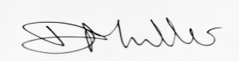

Dominique Muller, UK Policy Lead, Labour Behind the label
Lee Barron, Regional Secretary, Trades Union Congress Midlands, UK
Lucy Brill, Policy Lead – Private Sector, CAFOD, UK
Dr. Gisela Burckhardt, FEMNET, Germany
Mark Dearn, Director, Corporate Justice Coalition, UK
Joanna Ewart-James, Freedom United, UK
Cassie Farmer, GMB, UK
Nikolaus Hammer, Professor in Work and Employment, University of Leicester
Kate Hills, Make it British, UK
Jenny Holloway, Fashion Enter, UK
Dan Howard, Head of Good Work, ShareAction
Esmeralda Hoxha, Albanian CCC, Albania
Tarek Islam, Fashion-workers Advice Bureau Leicester, UK
Mario Iveković, Novi sindikat, Croatia
Jean Jenkins, Professor of Employment Relations, Cardiff Business School, Cardiff University, UK
Jay Kerr, Convener, No Sweat, UK
Eva Kreisler, Campaña Ropa Limpia, Spain
Carin Leffler, Future In Our Hands, Norway
Paddy Lillis, General Secretary, USDAW
Hilary Marsh, Transform Trade, UK
Liz McKean, Director of Campaigns and Policy, War on Want, UK
Jasmine O’Connor, Anti-Slavery International, UK
Mustafa Qadri, CEO, Equidem, UK
Konrad Rehling, Managing Director, Südwind (Austria)
Stephen Russell, Senior International Officer, TUC, UK
Raakhi Shah, CEO, The Circle, UK
Bojana Tamindžija, Clean Clothes Campaign Serbia / National Coordinator, Center for the Politics of Emancipation, Serbia
Priya Thamotheram, Highfields Community Centre, UK
Steve Trent, Environmental Justice Foundation, UK
Kristel Van Damme, Responsible Retail (AVC Puls), Belgium
Tara Van Ho, PhD., Associate Professor of Law and Human Rights, University of Essex, UK
Andrew Wallis OBE, Unseen, UK
Jennifer Wascak, Managing Director, Justice In Fashion CIC
Peter Williams, Homeworkers Worldwide
Carson Wind, Schone Kleren Campagne, CCC Netherlands

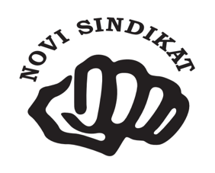

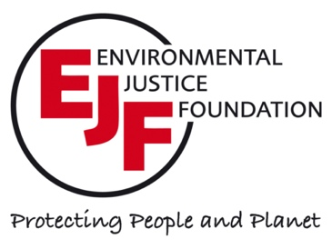

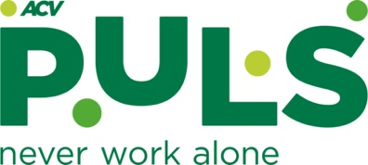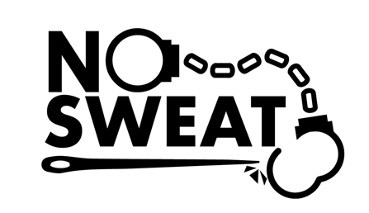
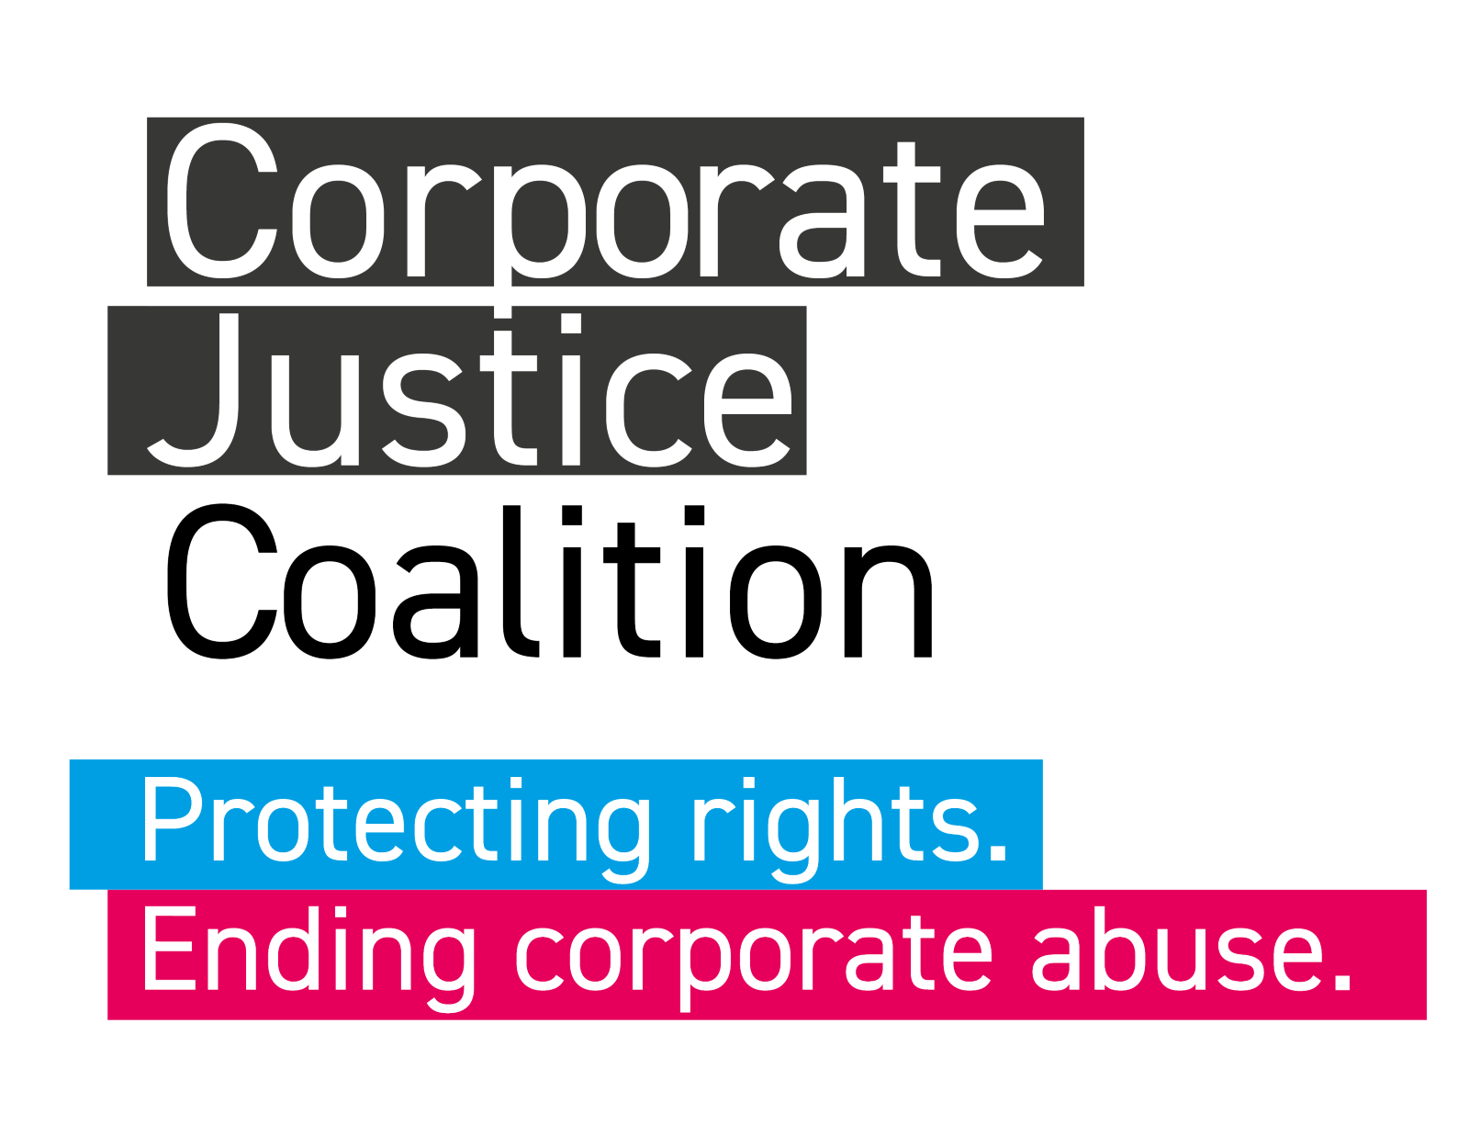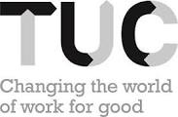

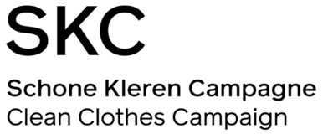

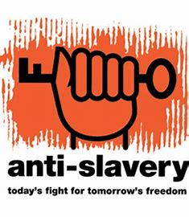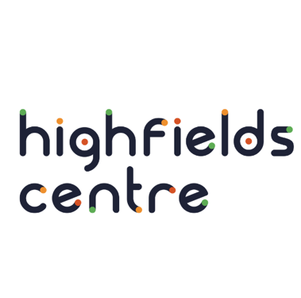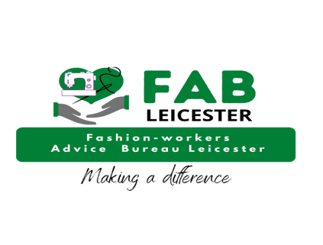

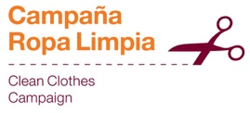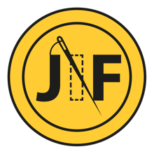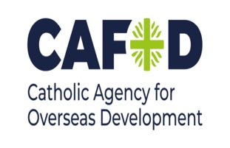

[https://labourbehindthelabel.net/wp-content/uploads/2020/07/Joint-Letter_re-Leicester-15-July-2020.pdf]
[https://corporatejusticecoalition.org/wp-content/uploads/2021/10/CJC-BHREA-Principles-2023-1.pdf]

